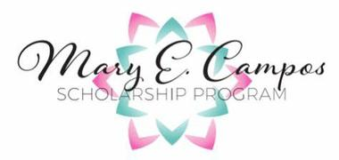
2021-2022 Awards

$2,500 Scholarship Award Recepient
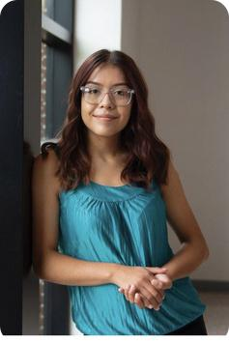
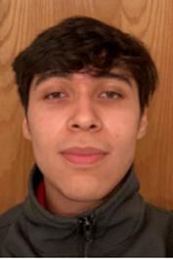

Caroly Coronado-Vargas

Al Éxito DSM, |drēm|sēd|, 9 years East High School 2020 Iowa State University

Statistics

Co-Founder ISU Al Éxito Collegiate

"The skills I have learned with Al Éxito have helped me advocate for myself and others going through the same struggles. Had it not been for Al Éxito, I would not be the person I am today."
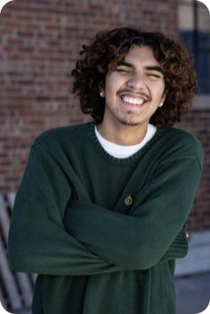

Agustin Oropeza

William Levia

Al Éxito DSM 4 years East High School 2022 Iowa State University

"Even with it being my last year in high school, Al Éxito has helped me more than ever. Being provided with guidance through the college process has not only helped me but my family as well."
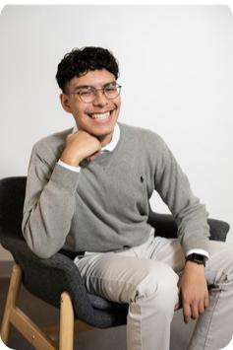

Juan Carlos Oropeza

Al Éxito DSM, |drēm|sēd|, Compa 7 years
North High School 2022

Iowa State University

Architecture

"Participating in Al Éxito as a student and leader for seven years has helped broaden my vision on real-world issues that Latinx students must overcome."

Al Éxito, |drēm|sēd|, Compa 9 years North High School 2020
Iowa State University

Pre-Med & Biological Pre-Medical

Illustration

Co-Founder ISU Al Éxito Collegiate

- My story begins with Al Exito in 6th grade. I have received an abundance of guidance and so many lessons from Al Éxito."

Naily Alvarenga

Al Éxito Ottumwa, 1 year Ottumwa High School 2021 Indian Hills Community College Surgical Tech

"Al Éxito has given me endless opportunities that have impacted my life already as a first year student."

$1,500 Scholarship Award Recepient
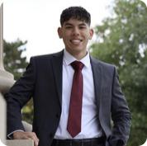

Roger Castillo | Ashley Castro | Diego Hernandez
Al Éxito DSM, Compa, 3 years | Al Éxito Ottumwa, 1 year | Al Éxito DSM, |drēm|sēd| 5
Hoover High School 2020 | Ottumwa High School 2022 | years
Iowa State University | Indian Hills Community College | East High School 2022
Mgmt. Information Systems | Nursing | Iowa State University
 |  | Veterinarian
"Coming from similar backgrounds | "Al Éxito has given me many | "Al | Exito exposed me | to the beauty
and sharing the same values, I have | opportunities and has helped me in
 |  | of | my culture and to | the riches of
found a community within Al Éxito.." | endless ways."
my skin."

Vanessa Hernandez Luis Lozano

Al Éxito Clarion, 1 year Al Éxito Ottumwa, 4 years

Clarion Goldfield Dows 2022 Ottumwa High School 2021

Grandview University Indian Hills Community College -

Interior Design Mechanical Engineering

"Coming into the program of Al Exito "Al Éxito has contributed greatly to the

has given me more visual points to see person I am today,"

the world in other eyes."

Jennifer Robles
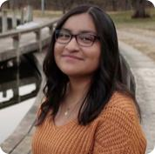

Al Éxito Collegiate, 1 year

Iowa State University

Software Engineering

"I heard about Al Exito and wanted to have a community where I can grow my leadership skills and celebrate my culture.."

$1,000 Scholarship Award Recepient

Orlando Fuentes Wilfrido Morales

Al Éxito DSM, |drēm|sēd|, 8 years Al Éxito DSM, |drēm|sēd|, 7 years

North High School 2021 East High School 2022

Drake University Indian Hills Community College -

Law Political Society and Music Culinary Arts

Performance

Daniela Zeledon

Al Éxito Ottumwa, 5 years

Ottumwa High School 2020

Iowa State University

Industrial Engineering

$500 Scholarship Award Recepient

Ximena Robles Karina Zenon Calles

Al Éxito Clarion 2 years Al Éxito Clarion 1 year

Clarion Goldfield Dows 2022 Clarion Goldfield Dows 2022

Iowa Central Community Indian Hills Community College

College - Animal Sciences Health Information Technology

Thank you sponsors!

Thank you to all the donors, volunteers, and sponsors for your support of Al Éxito and our students. Your support has given students the financial assistance needed to reach their higher education dreams! We would love for you to
attend the award ceremony. Please save the date!

Share with your friends and family!

Mary E. Campos Scholarship Awards Ceremony April 23, 2022 at 10:00 am via Zoom https://bit.ly/3DtcZT9
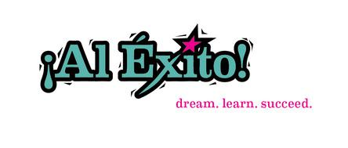

515-865-7195 | PO Box 93531, Des Moines, IA 50393

